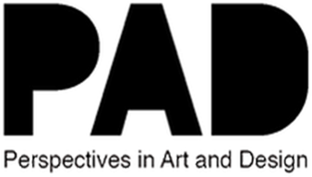
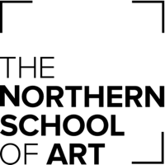
November 2022

The Story of MARRA Collective

Kyla Jean Hall, BA Hons Fine Art, Level 6

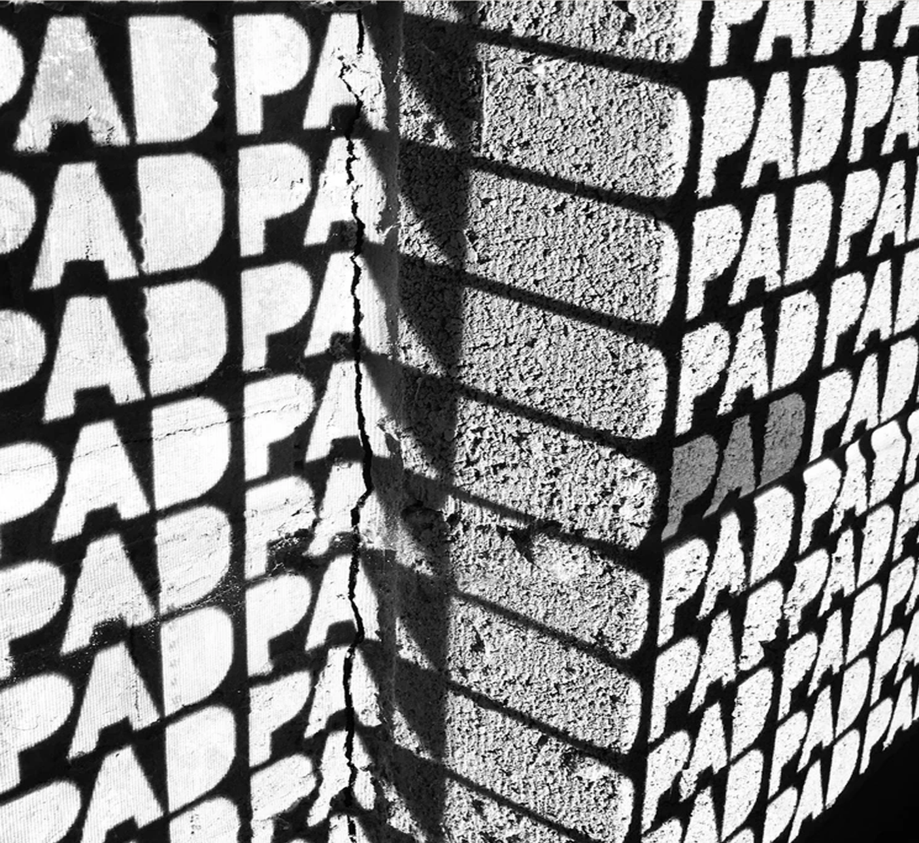

THE STORY OF MARRA COLLECTIVE
Author: Kyla Hall @Kylahallart

As with any good story, we must start at the beginning. In early 2022, three friends, artists, and students created The MARRA Collective to exhibit together, entitling the collective 'MARRA,' a northern word for friend, as a tribute to their friendship, education, and heritage. By presenting a varied variety of work and seeking exhibition opportunities, they hope to add something fresh to the art community and shine a light on the art being produced in the northeast.

MARRA collective showcases the work of nine artists studying at The Northern School of Art. Consisting of founder members Shelby Foster, Kyla Hall and Dana Ball, and artists Eboney Williams, Kate Oakey, Aimee Sulley, Chloe-Anne Smith, Ellie Cutmore, and Textiles and Surface Designer, Robin Mclaughlin.

As a collective, their work did not fit into a certain box due to their distinct approaches. They work in a variety of medium; sculpture, photography, painting, drawing and subjects, including still life, feminism, humanism, figurative, surrealism, art history, architecture, abstraction, and much more.
MARRAS popularity and success have flourished since then, from a handful of outcasts to a collective with a significant list of accomplishments under their belts. They have garnered a significant following on social media platforms, MARRA has also participated in exhibitions and having the chance to be a part of the organisation, responsible for advertisement design, in the first SARD Conference; Towards a feminist future, tackling the subject of feminism and sexism as a collective.

MARRA have been in conversations with galleries including Pineapple Black and the Wet Dove Tail gallery, recently securing a two-month show at Stockton Central Library. As individuals they have had opportunities to work with professional artists such as the fashion photographer Alice Hawkins, curate exhibitions, been offered solo shows, and now being a part of the academic publication PAD; Perspectives in Art and Design. In a span of just three months while still pursuing their academic studies in BA Hons Fine Art at The Northern School of Art, so much has been accomplished from this small group of students.

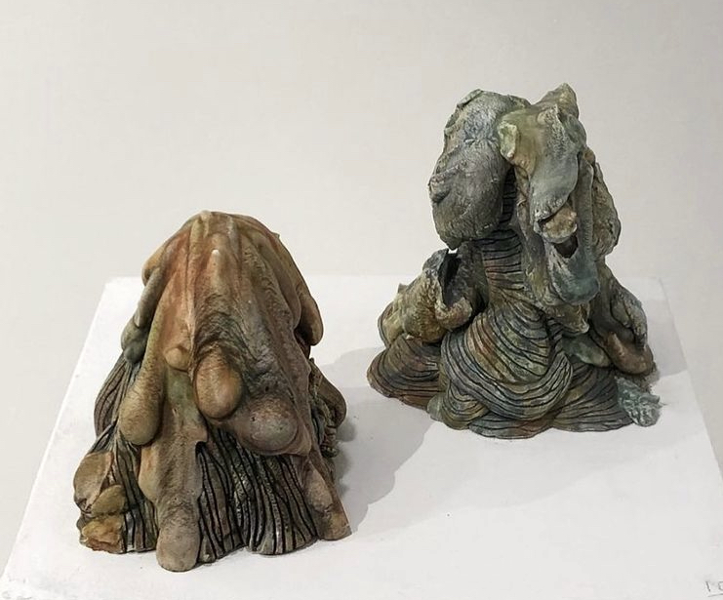

Shelby Foster, ‘Untitled’, 2022

THIS INTERVIEW WAS CONDUCTED ON THE 25TH MAY
I met with Shelby Foster, one of the MARRA Collective's three founders to gather a further information about the collective.

KH: Let’s start with how did MARRA begin?
SF: Personally, the idea came from a lecture by Dr Tony Charles in which he discussed collectives, and I thought to myself, "Let me get in on that!”. Together, with my friends Kyla and Dana we got together and established a group. We then started to recruit our friends.

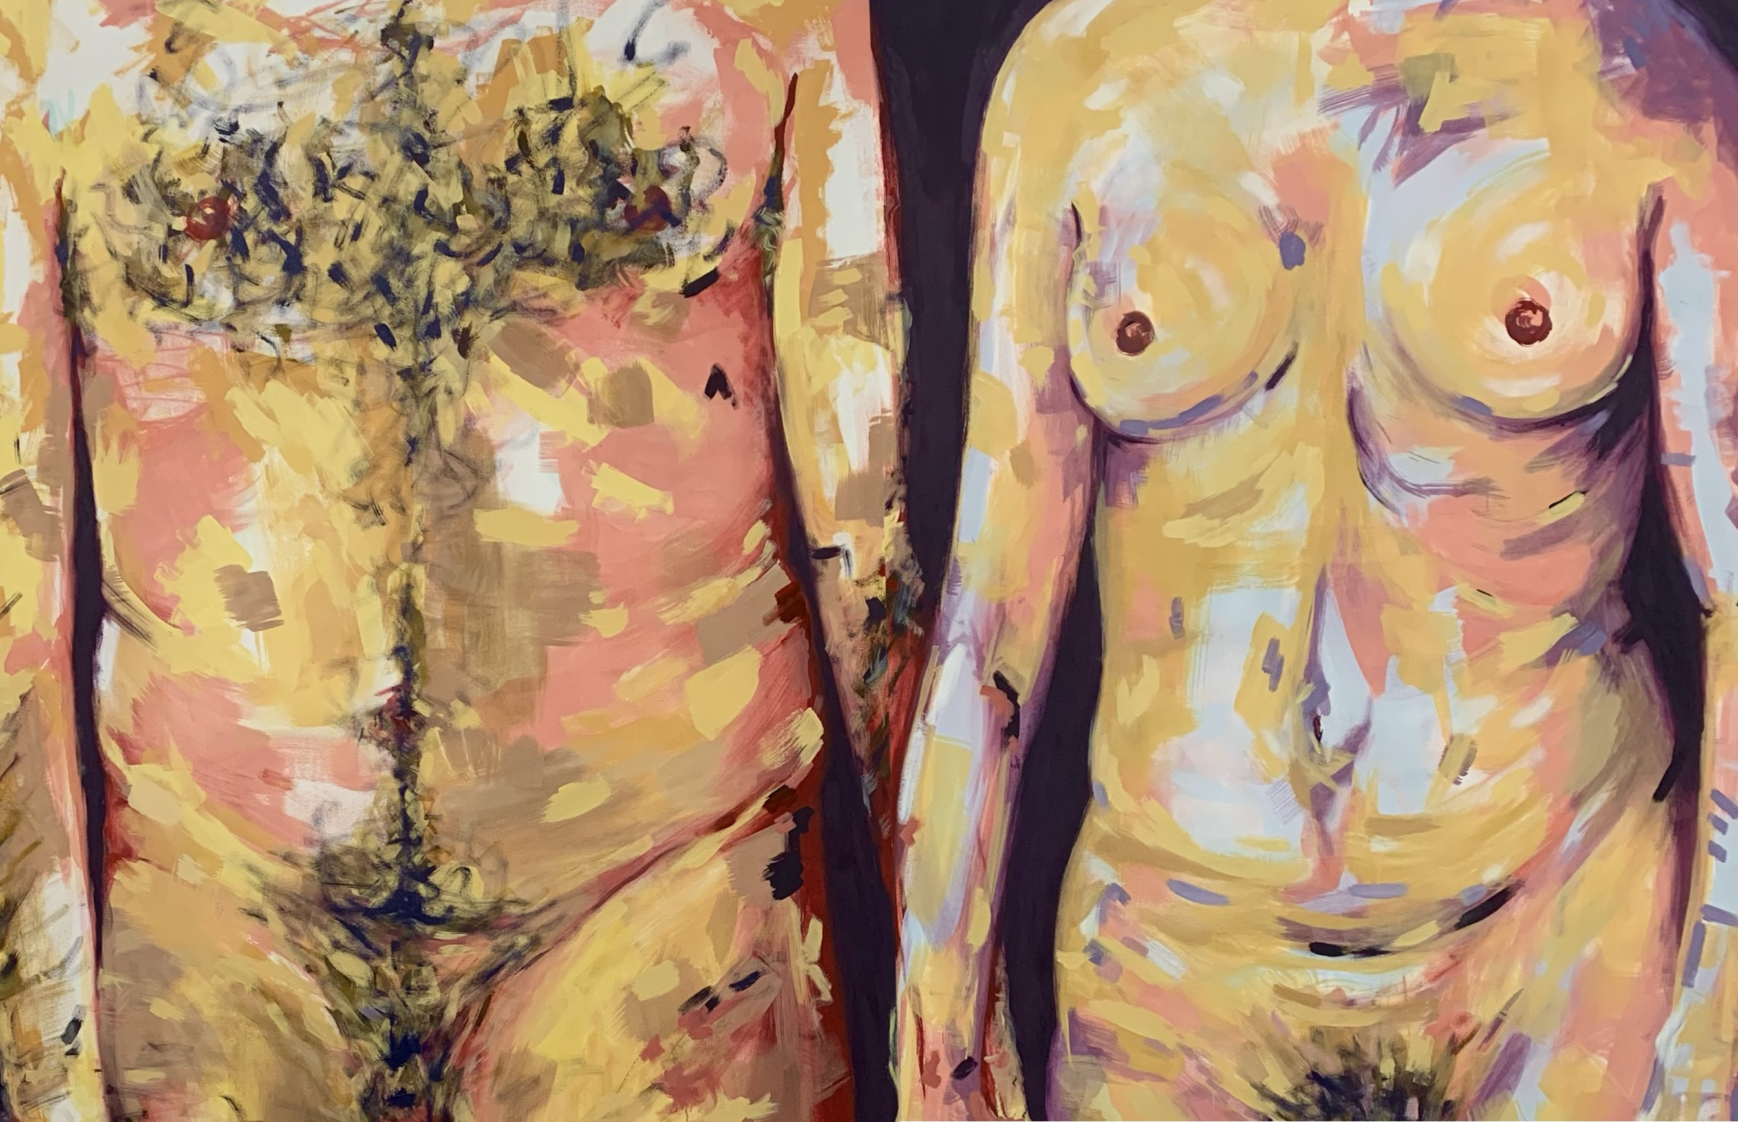

Kyla Hall, ‘Learn to love again’, 2022

KH: Can you tell me how you went from a group of three to now a group of nine?
SF: When I, Kyla, and Dana first started out, we just felt it would be wonderful to work together since we were familiar with each other, and then to attract members, we focused on people who had a great work ethic, a solid practice, and were friendly.

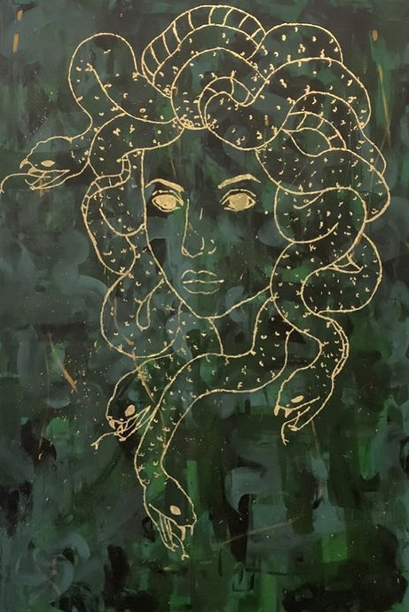

Dana Ball, ‘Medusa’, 2022

KH: So, there was a few boxes that needed to be checked? It was based on; work ethic, being a good worker, and being a genuine good person?
SF: Yes, everyone's practise is unique, and I believe that is what makes MARRA Collective so special. If everyone's thoughts, subject matter, and media were the same, it would be boring. It doesn't matter where you come from or your skill set; if you're a sculpture artist, a textile artist, or an illustrator, it's enough to simply be a creator. As long as you are easy to work with, you’re going to show up and be there, commit to the group, that’s what matters and what we will take into consideration.

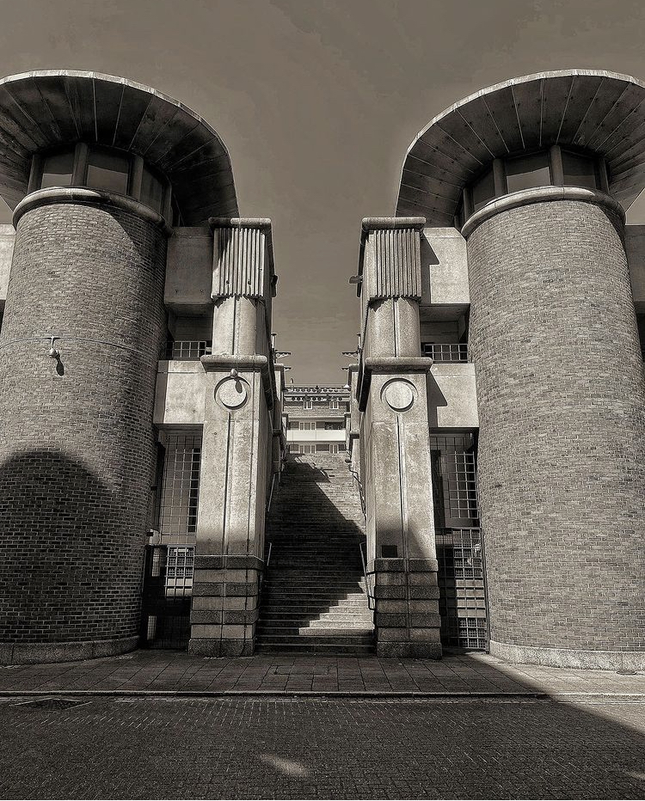

Ellie Cutmore, ‘Urban Newcastle’, 2022

KH: How does MARRA function as a group of nine people?
SF: When it comes to exhibitions, we must first understand what everyone is working on. I believe it is occasionally beneficial to assign responsibilities to people, such as the towards a feminist future conference. Ellie Cutmore organised the space, Kyla Hall and Eboney Williams did the digital marketing, and the pieces were hung collaboratively. I believe it's beneficial to have people take control as long as it's agreed upon in the group, so there's no drama, but there's no need to worry when you’re open and it's decided in the group.
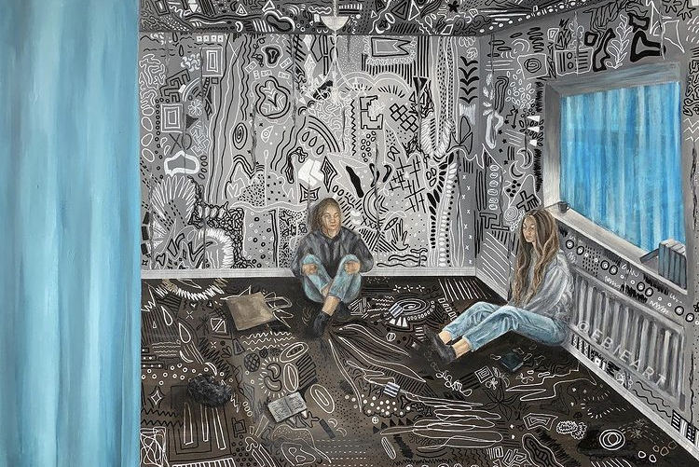

Eboney Williams, ‘Book Club’, 2022

KH: So, when you say everything is agreed in the group, is it fair to say communication is key to keeping this collective running smoothly?
SF: Definitely yeah, the collective doesn’t work without honesty. It could be the biggest problem or the smallest problem no matter what being honest with the group is necessary.

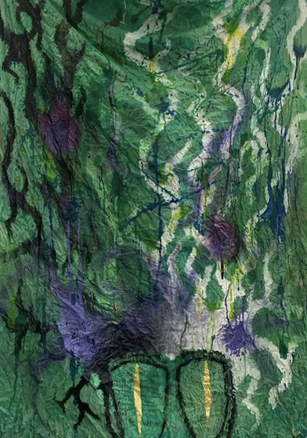

Chloe-Anne Smith ‘The Era of the Woman’ 2022

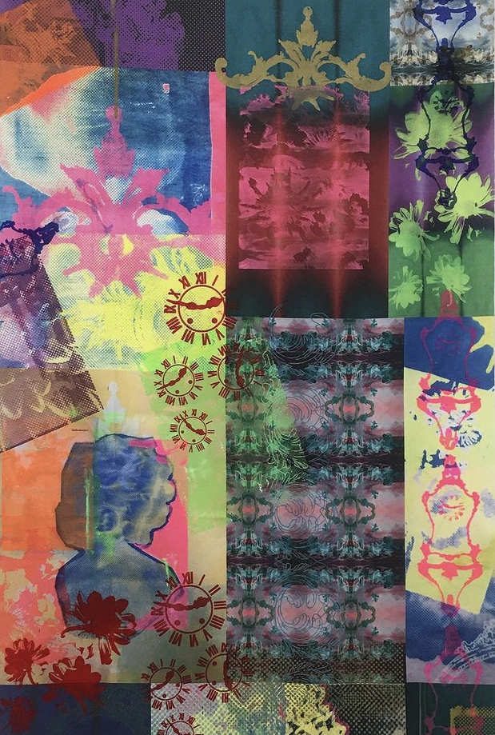

Robin McLaughlin ‘XXXXXX’, 2022

Robin McLaughlin, Club Rococo, 2022

KH: What are the advantages and disadvantages of working in a collective, what has been difficult and what has been rewarding?
SF: We've worked as outset and as MARRA, and I believe that no matter who you work with, you'll always have difficult times working in a huge group because people want different things, but that's what makes working in a collective so good. You have a choice in who you work with, and as long as you're working with individuals you can communicate with and who are reasonable, the problems fix themselves.
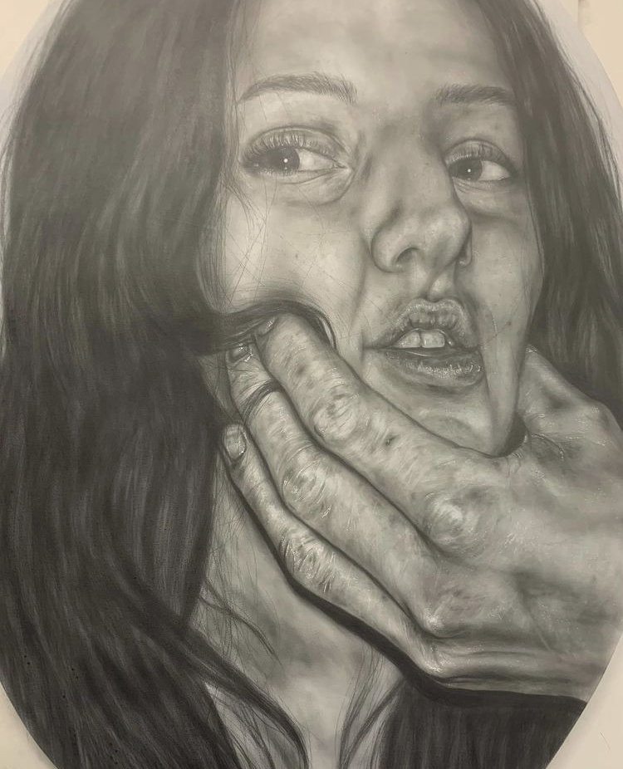

Kate Oakey, ‘I love you’, 2022
KH: MARRA at this time, has only existed for three months and you guys have a mass following in the hundreds on instagram, been a part of exhibitions, conferences. As individuals you have had opportunities to work with professional artists such as Alice Hawkins, curate exhibitions, been offered solo shows, personally asked to join scholarly activity research development groups and I could continue but now the collective is having an article written about them. What do you think makes people want to follow you? To what do you owe to your success?
SF: People follow us because they want to see what we're up to, therefore I believe it's critical to be active on social media. One thing MARRA is really excellent at is continually providing updates on what the group is up to, but it's not just the same person and the same artwork; you get to see the entire group's work. I think it demonstrates how dedicated we are to the collective, art and our practice.

KH: Are you proud of the collective?
SF: Yes, I am quite proud. When you said three months, it really put into perspective how much we've done and accomplished, especially given that we're all pursuing degrees.

KH: Where can people contact you for further information about the collective?
SF: For further information about the collective, if you want to get some advice, or if you have any exhibition opportunities you can contact us at marracollective@gmail.com or @marracollective on instagram.

My interview with one of the founders of MARRA, Shelby Foster gave us a great insight into their story, their highs and lows, pros and cons - as well as a glimpse into their humble beginnings and to their biggest successes together. Perhaps the group's most significant achievement, however, was the fact they found each other and became a poetic voice of today's artistic youth. If there is one thing for certain, it is that MARRA is a Collective to watch.

You can keep up to date with MARRA Collective and Shelby Foster by following their Instagram feed; @marracollective

MARRA Collective:
Shelby Foster @shelbyjade_art
Kyla Hall @kylahallart
Dana @dana_ball_art
Eboney Andrews @ebieart
Kate Oakey @kateoakeyart
Robin Mclaughlin @mclaughlintextiles
Aimee Sulley @asulley_art
Chloe-Anne Smith @cas.art21
Ellie Cutmore @elliecutmore.art
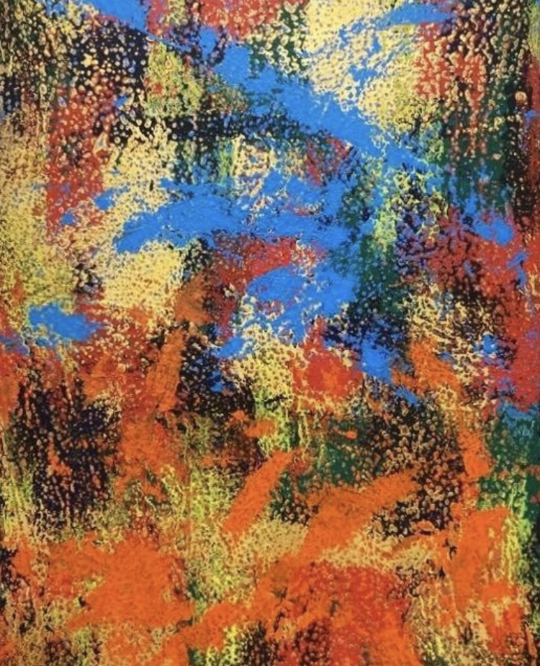

Aimee Sulley, Untitled, 2022

