

November 2022

***Review of Mark Pinder’s Exhibition ‘Macromancy: Britain and the North East of England 1986-2022’ at Hartlepool Art Gallery, July 2022***

Anna Tompkinson, BA Hons Fine Art Graduate of The Northern School of Art, 2022

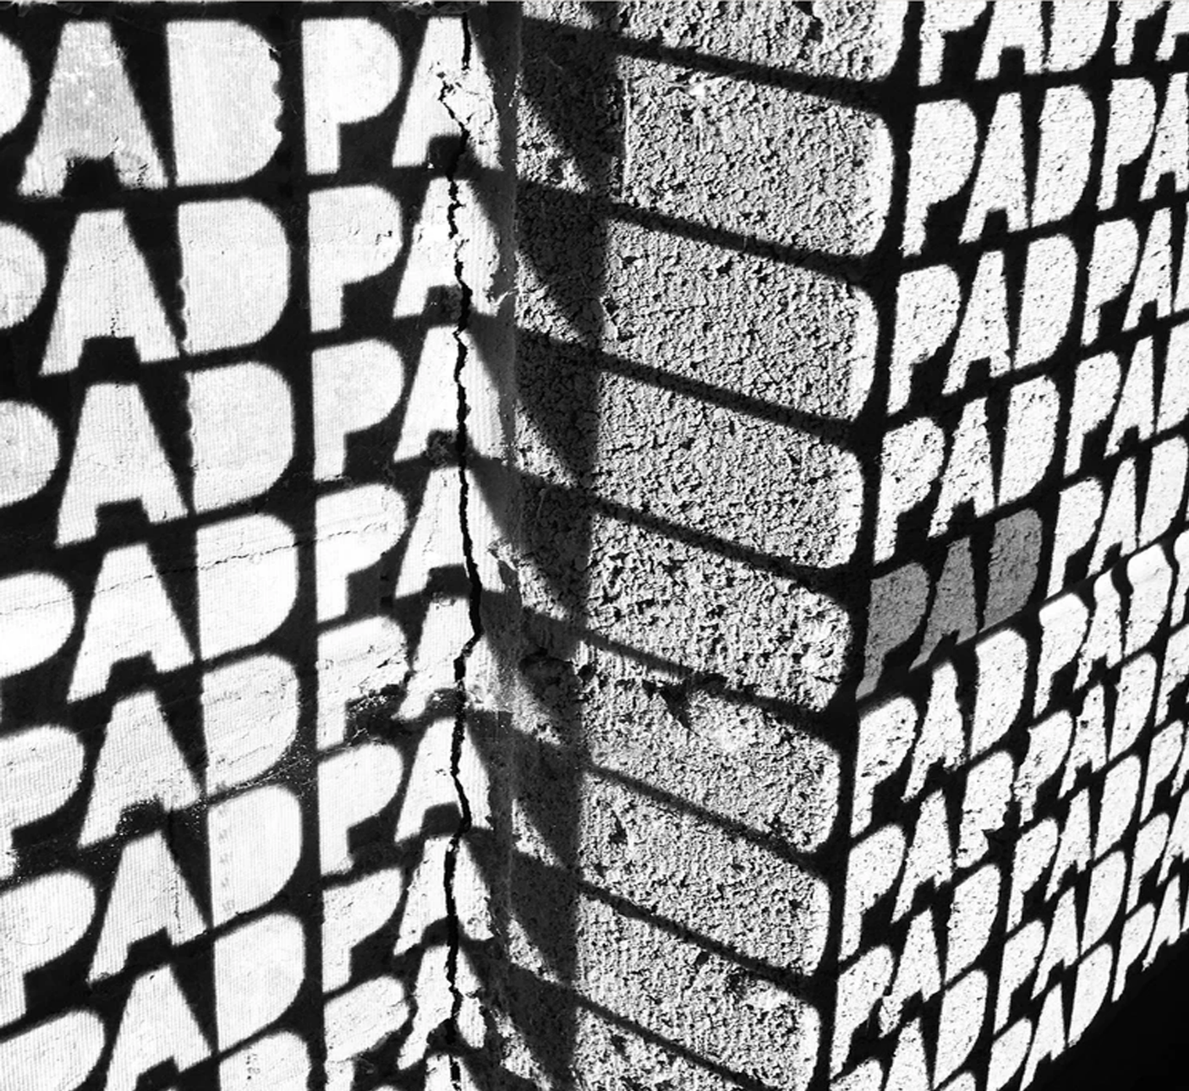

*‘Macromancy: Britain and the North East of England 1986-2022’* by Mark Pinder is Hartlepool Art Gallery’s latest exhibition. Pinder’s collective of photographs are a cumulation of a life’s work in journalism, accompanied by documentary photography from the time. Pinder is a photojournalist and documentary photographer, whose career has spanned over more than three decades. He has worked with an array of journalist clients, such as BBC and The Guardian; photographing current affairs and politics since the 1980s. His photographs document Britain and the North East; the landscape, the people, and their political standpoints over the last 30 years.

Pinder’s exhibition is curated into four ‘chapters’; each one documenting significant political periods in Britain and the North East of England from the 1980s onward. From Thatcher, to Blair, Cameron to Johnson; Pinder’s documentary and photojournalist photography creates a timeline that emulates the effects of politics, and the socio-economic fallout that comes with political backlash and anguish. Pinder’s work also features images that present the aftermath of political parties and their decisions, and how they have impacted key areas, such as industry.

The North East of England, in particular, was an ideal location to photograph and ultimately exhibit these changes through photographs, as this area was heavily impacted following particular political movements. Key political moments such as Thatcher’s industrial closures and the journey of ‘Brexit’ have all been documented through Pinder’s body of photographs, which depict an assortment of perspectives into each political advancement. From press shoots to political rallies, Pinder has immersed himself into capturing the conflicts and effects of political changes throughout the UK. Hartlepool is an incomparable location to display these works, as it still holds evidence of the social, political, and economic repercussions that have transformed the area over the years.

Pinder’s work features several key images that particularly stand-out as ‘key moments’ in political canon. *‘Margaret Thatcher, Scottish Tory Conference, Perth, Scotland, May 1989’* (Figure 1) is one of the first photographs in *‘Macromancy’*, which sets a strong tone for the exhibition to follow. The deceiving and ‘false’ nature that is present in Thatcher’s facial expressions within this image is an embodiment of her treatment of the working-class, particularly in Hartlepool.

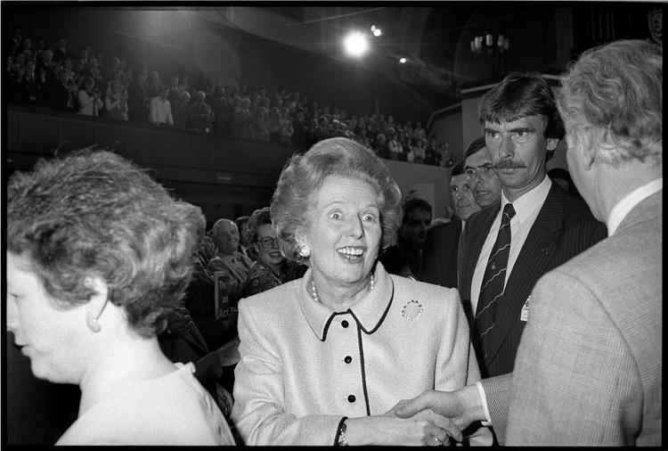

*Mark Pinder, Margaret Thatcher, Scottish Tory Conference, Perth, Scotland, May 1989*

Another key image from Pinder’s photographs is *‘Prime Minister Boris Johnson and Newly Elected Conservative MP for Hartlepool, Jill Mortimer, Hartlepool Marina, May 2021’.* Johnson is depicted as impassive and inexpressive; turned away from the camera. The tone of imagery is similar to Pinder’s image of Thatcher. Pinder takes a documentary approach to his images to capture the subject unposed; something that isn’t common amongst images of politicians and public figures. Having both images shown in the exhibition displays Pinder’s consistent approach to documenting political events, and his insight into social and economic rotations in Britain and the North East.

Pinder’s exhibition is an impressive documentation of witnessing the many political and socioeconomic events that have altered life in Britain from the 1980s onwards. The exhibition has displayed a sequential and progressive way to view and consider his images, allowing Pinder to showcase a lifetime of photojournalism and documentary photography in an impactful and reminiscent manner.

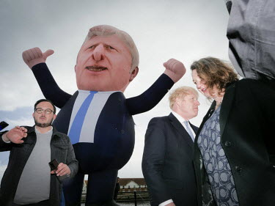

Mark Pinder, *‘Prime Minister Boris Johnson and Newly Elected Conservative MP for Hartlepool, Jill Mortimer, Hartlepool Marina, May 2021’*

*‘Macromancy: Britain and the North East of England 1986-2022’* is a photographic journey into the world of British politics. From media events to political protests, and elements of everyday life; Pinder invites the viewer to relive and reflect on events that have shaped Britain and the North East over the last three decades. He has pioneered an analytical portrayal and depiction of British politicians, which has allowed the viewer a categorical insight into British politics for over three decades. Pinder’s legacy is captured within this series of images and throughout this exhibition; completely expressing Britain’s political journey, and how it has influenced the lives and landscapes of the people.

**Image credits:**

*Mark Pinder, Margaret Thatcher, Scottish Tory Conference, Perth, Scotland, May 1989*

<https://markpinder.net/politics/2015/10/6/margaret-thatcher-perth-1990>

Mark Pinder, *‘Prime Minister Boris Johnson and Newly Elected Conservative MP for Hartlepool, Jill Mortimer, Hartlepool Marina, May 2021’*. Available at:

<https://m.facebook.com/markopinder/photos/a.1914793432119156/3143248162607004/?type=3&source=48&paipv=0&eav=Afa4Uo12gdUws1hQM9vt6OZRU0OvQFcCvY3rgcE9gC_9UZPy8vszW38Esyg4dTayeuA>